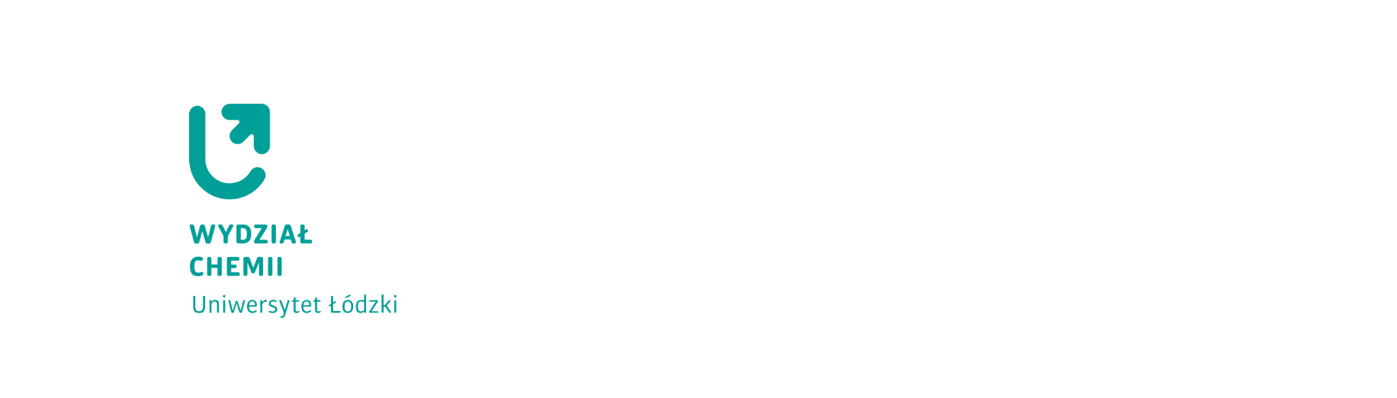**ANNEX 5 to Regulation No. 76 of the UL Rector of 22 April 2024**

TUITION FEES FOR PART-TIME STUDENTS

IN THE ACADEMIC YEAR 2024/2025

PART-TIME **BACHELOR’S DEGREE** STUDIES(3 years)

(CREDITED ON A SEMESTER BASIS)

**Programme**: CHEMISTRY: major: Chemistry

|  |  |  |  |  |
| --- | --- | --- | --- | --- |
| Year | Fee per year | Fee per semester | Amount of instalments for payment in 3 instalments for the **winter semester** | Amount of instalments  for payment in 4 instalments for the **summer semester** |
| I | PLN 4,500 | PLN 2,250 | I instalment - PLN 750  II instalment - PLN 750  III instalment - PLN 750 | I instalment - PLN 600  II instalment - PLN 550  III instalment - PLN 550  IV instalment - PLN 550 |
| II | PLN 4,500 | PLN 2,250 | I instalment - PLN 750  II instalment - PLN 750  III instalment - PLN 750 | I instalment - PLN 600  II instalment - PLN 550  III instalment - PLN 550  IV instalment - PLN 550 |