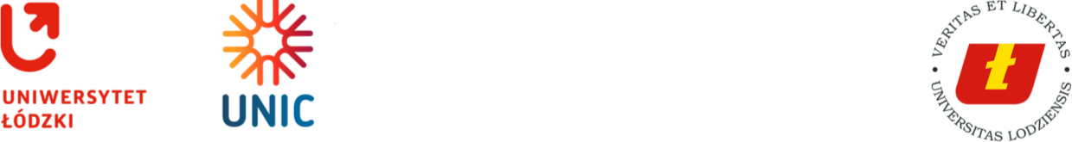

Regulation No. 113 of the Rector of the University of Lodz  
of 27 August 2024

**on: introducing the Rules and Regulations for academic degree recognition procedure, diploma recognition procedure and the procedure for confirmation of studies completed at a certain level**

Pursuant to Art. 327 and Art. 328 of the Act of 20 July 2018, Law on Higher Education and Science (consolidated text, Journal of Laws of 2023, item 742 as amended), it is ordered as follows:

§ **1**

The Rules and Regulations defining the academic degree recognition procedure, diplomas recognition procedure and the confirmation of studies completed at a certain level are introduced as an annex to this regulation.

§ **2**

This regulation comes into force on the day of its signing.

Vice-Rector for Research

1ST DEPUTY OF THE RECTOR

of the University of Lodz

Dr hab. Łukasz Korporowicz, Associate Professor